**Final Report**

**Architecture 643**

**Spring 2022**

**Software Analysis for HVAC Systems**

**in Low Energy Buildings**

Professor Charles Culp, Ph.D., P.E., FASHRAE, LEED-AP

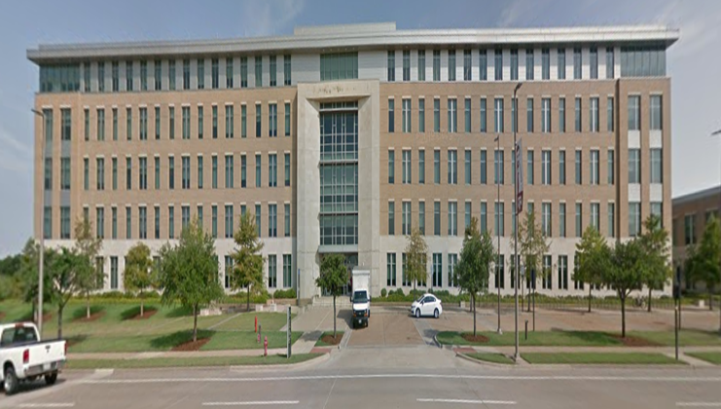

**Building Name:** Agriculture and Life Science Building (#1535)

**Students Names:** Di Lu, Yu Sun

**Date Submitted: 04/25/2022**

**Date Due: 04/25/2022**

# Table of Contents

Table of Contents 2

i. Acknowledgements 3

1. Appreciation 3

I. Introduction 4

1. Objectives 4

2. Building Description 6

3. Systems Description 9

II. Building Loads 13

1. People – Peak Interior Load 13

2. Lights – Peak Interior Load 14

3. Plug Load – Peak Interior Load 15

4. Solar – Peak Climate Sensitive Load 17

5. Outside Temperature – Peak Climate Sensitive Load 19

6. Outside Air – Peak Climate Sensitive Load 20

7. Total Building Loads 21

III. OpenStudio Baseline Modeling 23

1. District System 23

2. AHU (system) 28

3. Terminal Boxes - TB (zone) 29

IV. WinAM Modeling 31

1. AHU (system) 31

2. Terminal Boxes (zone) 31

V. Calibration 32

1. WinAM Calibration 32

2. OpenStudio Calibration 35

VI. EEM Opportunities 38

1. Building EEMs (system) 38

2. AHU EEMs (system) 38

3. Terminal Box (zone) EEMs 38

VII. Summary 39

1.Important Findings 39

2. Recommendations for Future Work 39

References/Standards 41

Appendix A. AHUs and FCUs Description 42

# i. Acknowledgements

## 1. Appreciation

This report was accomplished with the support from many people. First, I would like to express my sincere gratitude to Dr. Culp for guiding us as the introducer of the useful toolkits, EnergyPlus, OpenStudio, and WinAM. He has continuously provided us with necessary guidance with his patience.

I would also like to thank Mr. Chris Dieckert. His lecture, and introduction of the mechanical service website are the baseline and the guideline for us to create and calibrate the simulation models. His patience for helping us solve problems, such as provide us the series of project building mechanical system drawings has supported us to accomplish this report.

I would also like to thank Mr. Keith Bornmann for the field trip and introduction. The trip of showing and describing the real operation of equipment in a real building helps us to understand the working principles of the HVAC system, which is significant in the modeling progress.

# I. Introduction

## 1. Objectives

In this report, simulation models are created in OpenStudio and the energy savings analyses are accomplished in EnergyPlus, as shown in Table 1. Specifically, the baseline model, calibration model and the energy efficiency management (EEM) model are all build in OpenStudio. Building geometry is created based on the satellite images from Google Maps and on-site visit. The construction sets of the building is combined by the on-site observation and the information on the mechanical systems drawings. Schedules and building density are important for the HVAC system design. Therefore, the resources of these two categories are similar as the construction sets modeling. The district system, air handling unit system, and the terminal boxes in HVAC system is also done in OpenStudio. The parameters/inputs are based on the mechanical service website (Desigo) and the drawings provided from Mr. Chris. The EEMs measures are selected by the calibration model. We found that the EEMs we can use include the reducing lighting density, adding economizer, providing shading in windows (i.e., solar shelves), and night plug load reduction.

The energy reports are analyzed in EnergyPlus by month. We selected three variables and three meters to accomplish the analysis and comparison: outdoor air drybulb temperature, outdoor air humidity ratio, and outdoor air relative humidity for variables; electricity for building, district cooling and district heating for meters. We took advantage of the Excel spreadsheet to convert the energy use in Joule units to kWh and money cost to accomplish the energy savings analysis.

Table 1. Objectives of the Simulation Model in OpenStudio and EnergyPlus

## 2. Building Description

The Agriculture and Life Science (#1535) Building is in west TAMU campus (600 John Kimbrough Blvd #510, College Station, TX, 7784). This is a five-story lecture building, with an angle 67.1° from the north axis (as shown in Figure 1and Figure 2).

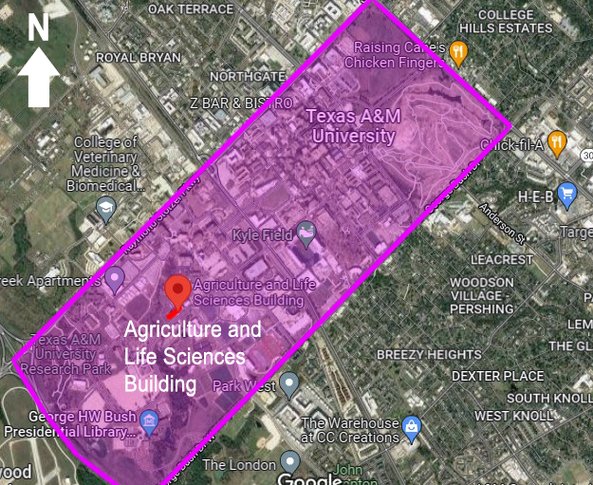

Figure 1**.** Building Location (in Campus)

This building is in rectangle shape layout. The length of the building is 120m (400ft) and the width is 22m (70ft), as shown in Figure 3. The area of one floor is 2,684m2 (28,890.34ft2), and the total area of the building is 13,420m2 (144,451.68ft2).

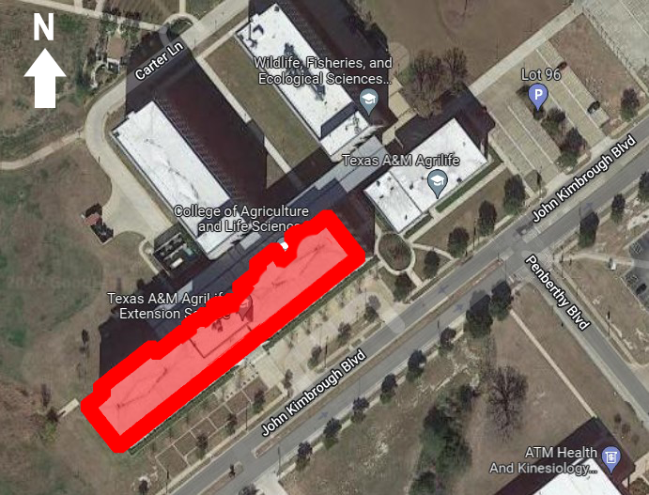

Figure 2. Building Location (Enlarge)

The building window to wall ratio (WWR) is calculated to be 25% on the 1st floor of the South wall; 23% on the 2nd, 3rd, and 4th floor of the South wall; 33% on the 5th floor of the South wall. The window to wall ratio is 22% on the 1st, 2nd, 3rd, and 4th floor of the East and West wall; 33% on the 5th floor of the East and West wall. On the North façade, the 1st Four WWR is similar as the South façade; however, as the window area design next to the central lobby on the North wall is less than the South area, it could be calculated with 24%. In addition, the window area in the central lobby on the North wall is less than the South one; therefore, the WWR on the 2nd, 3rd, 4th floor is 22%. The 5th floor WWR on the North façade is equal to the South, which equals to 33%. The doors are created in the South side of the building with dimension 2.7m (8.86ft) (H) x 2m (6.56ft) (W), in 4 groups. The door on the west and east side of the building has dimension of 2m (6.56ft) (H) x 0.7m (2.3ft) (W). Two doors are installed in the North wall, one is on the east corner with 2.7m (8.86ft) (H) x 2m (6.56ft) (W), in 4 groups; the other is in the central lobby area in the same dimension with 2 groups. The floor to ceiling height is 3m (9.84ft) and the above plenum height is 0.6m (1.97ft). Table *2* shows the details of the dimensions.

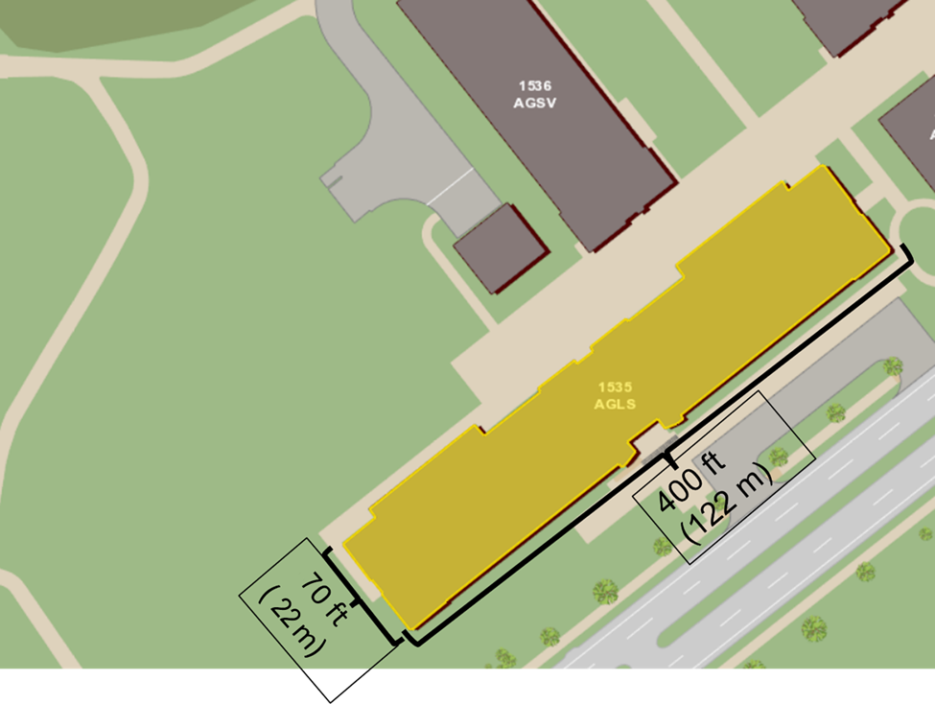

Figure 3. Building Layout Dimensions

|  |  |  |  |  |  |
| --- | --- | --- | --- | --- | --- |
|  | Floor dimension (m*m) | Floor to ceiling height (m) | Above ceiling plenum height(m) | Window to wall ratio | Door dimensions (m*m) |
| Building modeling dimensions | 122 * 22 | 3.0 | 0.6 | **Floor 1:**  0.25 (S)  0.23 (E & W)  0.24 (N)  **Floor2-Floor4:**  0.23 (S)  0.23(E & W)  0.22 (N)  **Floor 5:**  0.33 (S & N)  0.33 (E & W) | **South (4 groups):**  2.7(H)*2(W)  **East & West:**  2.4(H)*0.7(W)  **North:**  **1) 4 Groups**  **East Corner**  2.7(H)*2(W)  **2) 2 Groups**  **Central Lobby**  2.7(H)*2(W) |

Table 2. Building Dimensions Details

Combing the on-site visit, the information in the Desigo website and the mechanical drawings, the key HVAC system in this project include four categories, air handling unit (AHU), fan coil unit (FCU), heating recovery ventilators (HRV) and terminal box (TB). More detailed information will be discussed in the Systems Description section.

## 3. Systems Description

As mentioned above, the Agriculture and Life Sciences Building is a five-story lecture building. The floor plans are shown from Figure 4 to Figure 8[1]. However, the floor plans from the Decigo website are missing the central lobby area. In other words, the website shows the east and west parts of every floor in the building. Therefore, we added the central lobby area based on the reasonable scale ratio in all five stories.

The floor plans in the Decigo website also directly indicate the rooms covered by every air handling unit (AHU) and the main mechanical equipment rooms in each floor. The orange color represents the rooms that each AHU covers; the green color represents the fan coil unit (FCU); and the light blue color represents the computer room air conditioning (CRAC) room (Room 123).

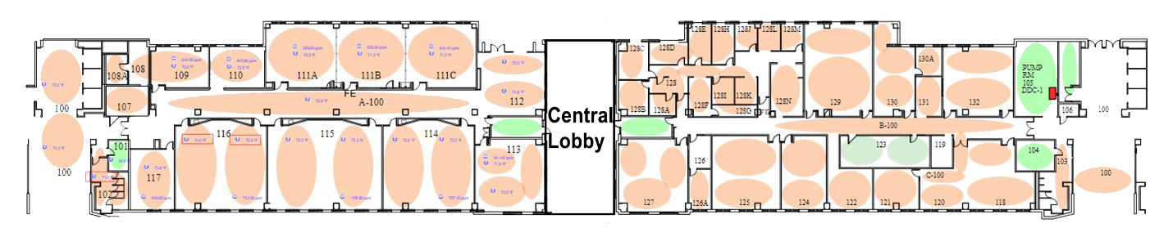

AHU

FCU’s

CRAC

Figure 4. 1st Floor Plan

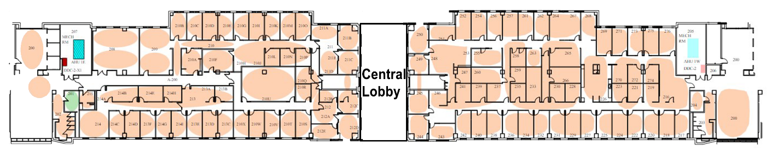

Figure 5. 2nd Floor Plan

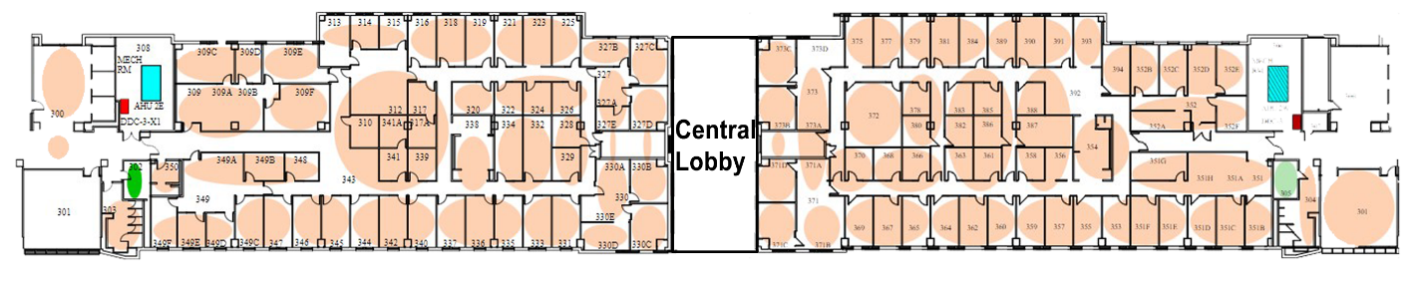

Figure 6. 3rd Floor Plan

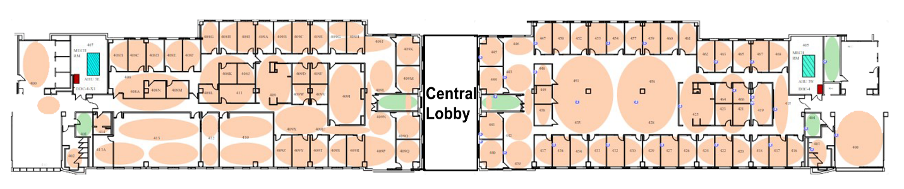

Figure 7. 4th Floor Plan

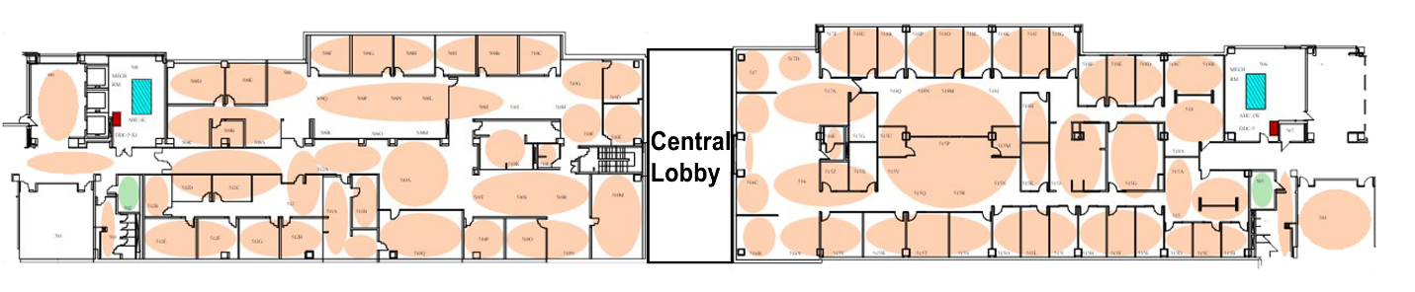

Figure 8. 5th Floor Plan

Combining the five floor plans, we decided to separate five thermal zones each floor, four exterior thermal zones (Zone 1 to Zone 4) and one interior thermal zone (Zone 5). We used third floor as the example to show how we separate the thermal zone on one floor, as shown in Figure 9. Zone 1 locates on the west area; Zone 2 locates on the south area; Zone 3 locates on the east area; Zone 4 locates on the north area. Combing with the exterior wall façade and the interior rooms layout, the dimensions of the Zone 1 and Zone 3 in each floor are 8m (26.25ft) (L) x 22m (70ft) (W); and 106m (347.77ft) (L) x 4m/13.12ft (W) of Zone 2 and Zone 4 (each floor). The Zone 5 in each floor is 106m (347.77ft) (L) x 14m (45.93ft) (W). The total area of each zone (all five stories) is followed: 880m2 (9,472.24ft2) (Zone 1 and Zone 3), 424m2 (4563.90ft2) (Zone 2 and Zone 3), 1,484m2 (15,973.64ft2) (Zone 5).

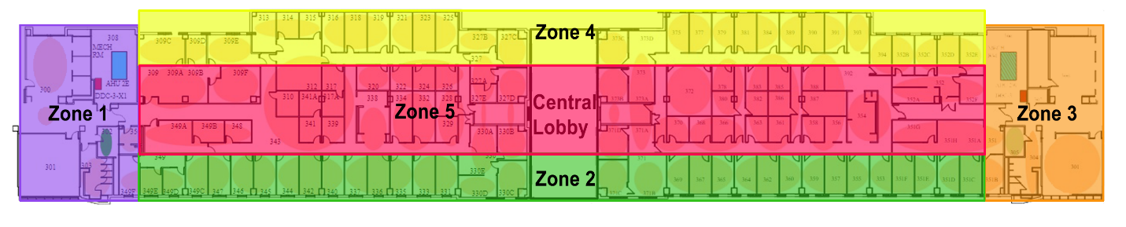

Figure 9. Floor Plan Example for the Thermal Zones Separation

According to the floor plans, the simulation model is created in the Open Studio program. Figure 10 shows the simulation thermal zones on the 1st floor as the example. The other thing would like to mention is the shading in the north area. A two-story height shading in front of the North wall, which is 3m/9.84 ft far from the wall. It is 42m (138.80ft) away from the West wall. The dimension of the shading is 80m (262.47ft) (L) x 12m (39.37ft) (W).

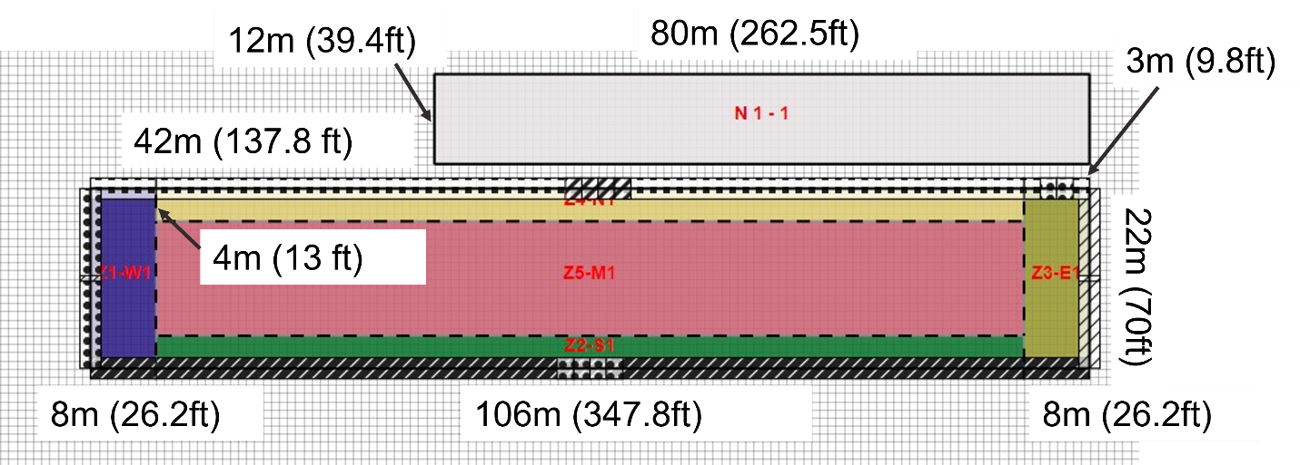

Figure 10. Thermal Zones in 1st Floor in Open Studio Model (Example)

The HVAC system in the project includes five AHUs, seventeen FCUs, two HRVs and one hundred and twenty-five TBs. The AHUs are located in each floor, and every AHU serves the specific floor it locates at. FCUs locate at the mechanical rooms and stairs in the North and South facing. Similar as AHUs, every floor has specific working FCUs. The AHUs and FCUs schedules are shown in Appendix A.

Table 3 shows the detailed feature descriptions of the four main HVAC system categories.

|  |  |  |  |  |
| --- | --- | --- | --- | --- |
|  | **Number** | **Motor Horsepower (hp)** | **Total Air Flow (cfm)** | **VFD** |
| **Air Handling Unit** | 5 | 15 | 62,500 | Yes |
| **Fan Coil Unit** | 17 | 7 | 12,100 |  |
| **Heating Recovery Ventilators** | 2 | - | - |  |
| **Terminal Box** | 125 | - | - |  |

Table 3. Key HVAC System Features

# II. Building Loads

## People – Peak Interior Load

Building energy consumption is dominated by occupants. All occupant behaviors will play a significant role on cooling and heating loads, including the occupant density. Human beings are one of the main internal heat gains for the indoor environment; in other words, it increases the cooling and heating loads with a high occupancy density. In addition, the carbon dioxide density will also increase with more people inside, and more fresh air is required. As a result, it will grow the air flow rate and the HVAC operation time so that make the cooling and heating loads gain.

Based on the ASHRAE 90.1-2019 Standard, the peak occupancy density for school and university is 40ft2/person (4m2/person)[2]. In the model, we used 12m2/person as the peak occupancy density value which is one fourth of the value in the Standard 90.1-2019. As a result, the number of people in the building equals to 1,200 in the peak period. The number of people in each zone is followed: 74 people (Zone 1 and Zone 3), 36 people (Zone 2 and Zone 3), 619 people (Zone 5).

On the other hand, according to the Standard (2019), the sensible load in the university is 250 Btu/h-person (72.5 W/person) and the latent load is 200 Btu/h-person (58 W/person). Therefore, the sensible loads in Zone 1 and Zone 3 are 5,365 W, following 2,610 W in Zone 2 and Zone 4 and 44,877.5 W in Zone 5. For the latent load, it is 4,292 W in Zone 1 and Zone 3, 2,088 W in Zone 2 and Zone 4, and 35,902 W in Zone 5.

According to the ASHRAE Standard 90.1 – 2019, Schedule G2, the occupants schedule should distinguish the weekday and weekends. In addition, as the project building is an educational building, it should also make a distinction between during semesters and summer break (05/31 – 7/31). Combing the ASHRAE Standard schedule, the on-site visit, and the measured energy data analysis, Table 3, and Figure 11 show the occupancy peak load schedule. The highest people peak load is from 9:00 am to 5:00 pm, represents 90% on semesters’ weekdays, and approximately 50% on weekends and summer break; while as the summer courses, the peak load exact value in summer break is higher than on semesters’ weekends.



Table 4. Occupants Schedule



Figure 11. People Peak Interior Load

## Lights – Peak Interior Load

The lighting power density (LPD) of school/university is 0.72 W/ft2 (7.72 W/m2) in ASHRAE 90.1[3]. On the other hand, it is observed that the light in the building is T-8 fluorescent lights. Combing with the ASHRAE Standard, and the on-site observation and calculation, the LPD of the project building is 1.39 W/ft2 (15 W/m2).

Similar as the occupancy schedule, the lighting operational schedule is also distinct into semesters weekday and weekend and summer break. The highest peak load is from 9:00 am to 5:00 pm on weekdays (semesters). The summer break lighting schedules are almost the same as the weekdays during semesters, while the peak load value is about 90% of the one on weekdays in fall and spring semesters. The schedule on weekends in the two semesters is about 30% less than in the workdays; while the peak load is the lowest in the three period (61%).



Table 5. Lighting Operational Schedule



Figure 12. Lighting Peak Interior Load

## Plug Load – Peak Interior Load

Table 5 and Figure 13 show the operational schedule for the plug loads in the project building. Based on the on-site visit, the equipment in the building includes computers, projectors, conference room equipment, etc. The electric equipment density in the model is 10 W/m2.

As the equipment always keep turning on or in sleep mode, especially during the two semesters, it is expected to have peak usage in classes time during 9:00 am to 5:00 pm (80%). The equipment operational schedule on workdays and weekends during two semesters periods are the same. In addition, although the plug loads on weekdays and weekends during semesters, and summer break are in the same values at night, the peak usage value of weekdays and weekends in the two semesters is over 10% more than the values on summer break.



Table 6. Equipment Operational Schedule



Figure 13. Equipment Interior Peak Load

## Solar – Peak Climate Sensitive Load

Solar load also influences the equipment sizing. The solar load in this report illustrates the solar heat gain (SHG) from the fenestrations (windows and glazing doors). The SHG describes the solar radiation turns into heat. The factors that impact SHG include the fenestration material, building orientation, solar position, solar heat gain coefficient (SHGC), etc. The formular is as followed:

$Solar Load=Solar Heat Gain Factor*Window Area \left(Face of Building\right)* Shading Coefficient$

where Shading Coefficient = SHGC/0.86

According to the ASHRAE Standard 90.1-2019, the SHGC of fixed window in Climate Zone 2 is 0.252. Based on the Solar Heat Gain Factor for selected latitude table[4] (shown as Table 5), the peak solar loads of the project building are shown on Table 6 and Figure 14.



Table 7. Solar Heat Gain Factor for Selected Latitude

As the building orientation is 67.1 degree to the N axis, therefore, the North, West, South and East of the #1535 building is Northeast, Southeast, Southwest and Northwest orientation on the map. Based on the diagram, it can be seen that the SHG in the North and South building façades is higher than the East and West façades. The peak solar load in the South and East is 120 kW/day, which is approximately 1.4 times than the peak load in the North and West. However, the SHG trend in the South and East areas is higher gain in winter period, while lower gain in summer period. In contract, the SHG trend in the North and West areas is higher gain in summer, but lower gain in winter.

The highest total solar peak climate sensitive load of the four façades is in June, which is 328.42 kW/day.



Table 8. Solar Heat Gain on Each Façade



Figure 14. Solar – Peak Climate Sensitive Load

## Outside Temperature – Peak Climate Sensitive Load

Building envelope elements of the project building includes walls, roof, ground floor and fenestration (windows and glazing doors). The temperature difference between the indoor air and outdoor air occurs heat losses in buildings. It can follow the formula to calculate the amount of heat loss/gain:

$$Q = U * A * ΔT$$

where Q: Heat Flow (W or $\frac{Btu}{hr}$)

U: Heat transfer coefficient ($\frac{W}{m2-K}$ or $\frac{Btu}{hr-in2-F}$)

A: Area (m2 or ft2)

ΔT: Toutdoor – Tindoor (ºC or ºF)

The high temperature is based on the temperature on Summer Design Day, and the low temperature is based on the temperature on Winter Design Day. Specifically, the high temperature is 98.6 ºF (37ºC), and the low temperature is 26.06ºF (-3.3ºC). In the on-site visit, we found that the indoor temperature is maintained at 72ºF (22 ºC) in summer, and

70 ºF (21 ºC) in winter.



Table 9. Outside Temperature – Peak Climate Sensitive Load

Table 8 summarizes the heat loss/gain for different building envelope elements. The U-values is based on the ASHRAE Standard 90.1 -2019. The roof material is chosen as the insulation entirely above deck; the walls above Grade are chosen as mass; the floor is chosen as mass; and the fenestration is chosen as the fixed windows.

Based on the table, it is seen that the largest heat loss/gain is in winter (-186.73 kW). As it is a negative value, it describes that it is heat loss of the building envelope elements in winter.

## Outside Air – Peak Climate Sensitive Load

Fresh air is important for the indoor air quality and occupants’ health. However, because of the temperature difference and the humidity difference between the return air and outdoor fresh air, it requires to provide better design on the minimum the outdoor fresh air amount so that to increase the HVAC system efficiency. Oversizing or less-sizing outdoor air rate may cause more HVAC loads. The equation of the outside air amount is followed:

$$Q= (ρ(air) * q) * cp * ΔT$$

where Q: Heat flow (W or $\frac{Btu}{hr}$)

ρair: Air density at standard conditions ($\frac{kg}{m3}$ or $\frac{lb}{ft3}$)

q: Air flow ( $\frac{m3}{hr}$ or $\frac{ft3}{min}$/cfm)

cp: specific heat of air ( $\frac{J}{kg-K}$ or $\frac{Btu}{lb-F}$)

ΔT: Toutdoor – Tindoor (ºC or ºF)

Based on the ASHRAE 62.1 – 2019 (Table 6-1)[5], the outdoor air flow for a classroom is 10 cfm/person. As mentioned, the peak number of occupants in the building is 1,200; therefore, the outdoor air flow equals 12,000 cfm (20,388.13 $\frac{m3}{hr}$).

When considering the HVAC system sizing, it requires the largest heat flow in all aspects, including occupants, lighting, plug loads, solar and outside air (OA). In this project, the total largest heat flow equals: 84.24 kW (occupants) + 152.99 kW (lighting) + 93.94 kW (equipment) + 69.85 kW (solar) + 115.26 (OA) = 516.28 kW. According to the formula mentioned above, the air flow is 151,846.34 $\frac{m3}{hr}$ or 89,373.38 cfm. The OA value based on the Standard 62.1 is approximately 13% of the OA value in the project.

On the other hand, the temperature difference in the HVAC load calculation considers the damper and the interior thermostats. In this case, the damper temperature/deck temperature is 55 ºF (12.8 ºC), and the interior thermostat temperature in summer is 72ºF (22 ºC), and 70 ºF (21 ºC) in winter.



Figure 15. HVAC Load in Summer

## Total Building Loads

Figure 16 (for summer) and Figure 17 (for winter) are the graphs show the total building loads, occupants, lighting, equipment, solar, outside temperature and outdoor air. In the two graphics, it describes that the outside air load requires the largest energy consumption, following with lighting load. However, the peak total power usage in summer is about 2.3 times than the peak total power usage in winter. On the other hand, the third largest energy consumption building load is outside temperature in summer, while people load ranks the third largest in winter.

As mentioned in the outside air section, the largest total building power usage in summer equals: 84.24 kW (occupants) + 152.99 kW (lighting) + 93.94 kW (equipment) + 69.85 kW (solar) + 115.26 (OA) = 516.28 kW. In addition, the largest total building power usage in winter equals: 84.24 kW (occupants) + 152.99 kW (lighting) + 93.94 kW (equipment) + 80.07 kW (solar) + (-186.73 kW) (OA) = 224.51 kW. These two values are the significant references and guidelines for the cooling and heating design.



Figure 16. Total Building Loads – Summer



Figure 17. Total Building Loads - Winter

# III. OpenStudio Baseline Modeling

## District System

Figure 18 and Figure 19 describe the supply and return temperature ranges for both hot water and chilled water. The chilled water is supplied at around 40-45 °F with a delta-T of 15- 20 °F. This potentially indicates at current design mass flow rate; the building is consuming a large amount of cooling to remain comfort. On the other hands, the hot water is provided with 140-160 °F with a delta-T of 8-12 °F in Winter and delta-T of 0-5 °F in summer. The hot water usage in summer is smaller compared to winter hot water usage. The monthly electricity, chilled water and hot water usage are shown in Figure 20, Figure 21, and Figure 22. The monthly electricity usage doesn’t show much dependency on months.

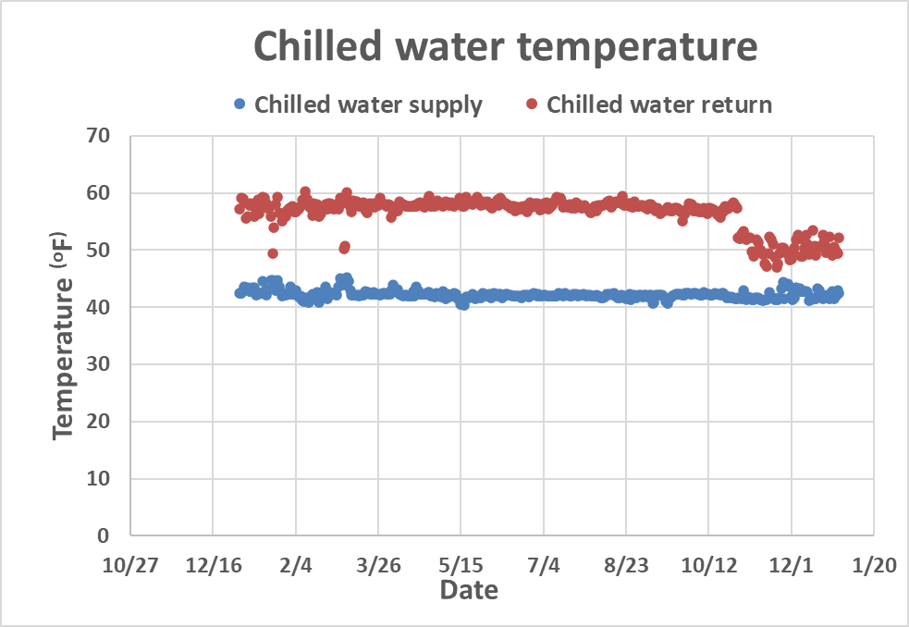

Figure 18. Chilled water supply and return temperature.

~~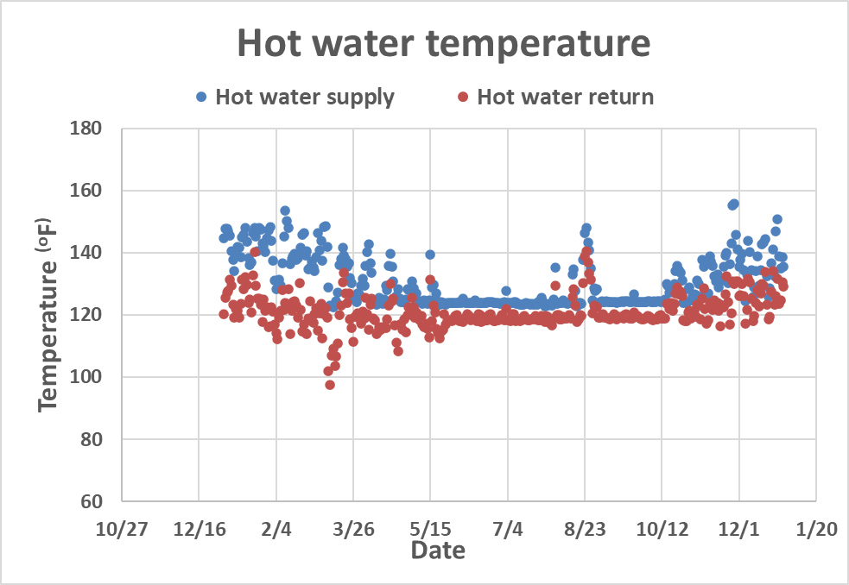~~

Figure 19. Hot water supply and return temperature.

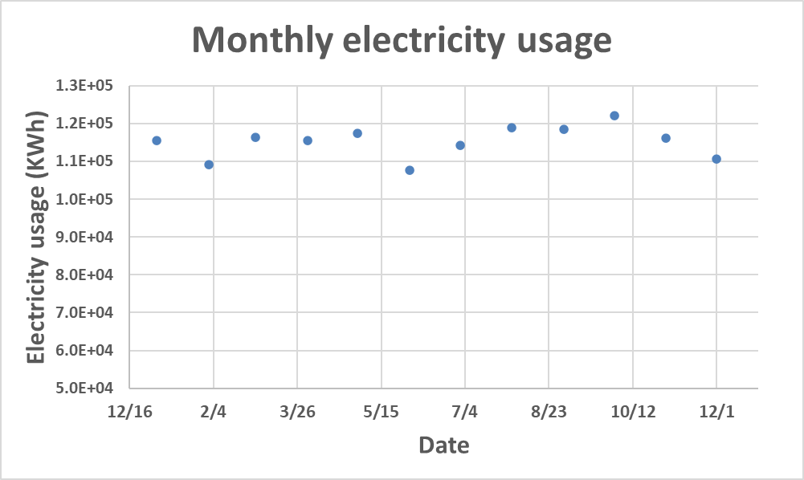

Figure 20. Monthly electricity usage.

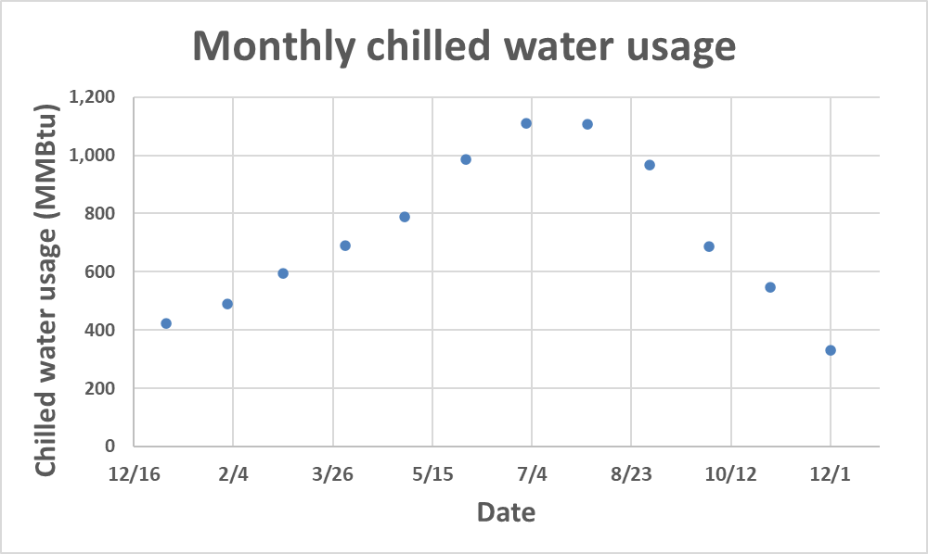

Figure 21. Monthly Chilled water usage.

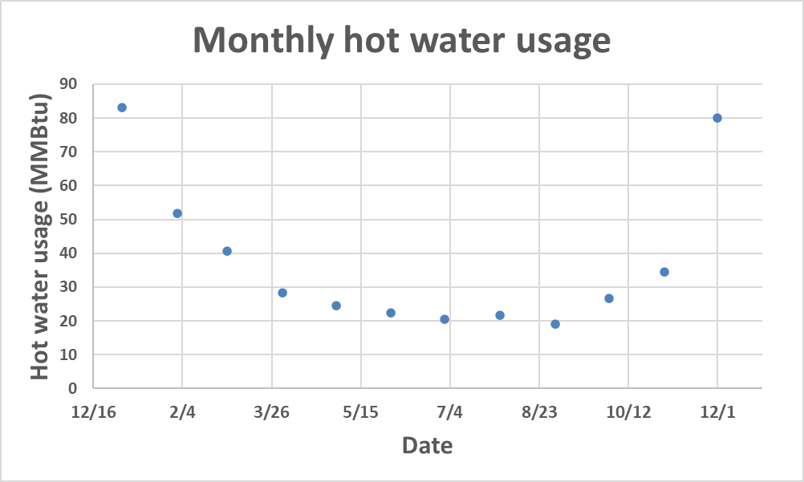

Figure 22. Monthly hot water usage

The chilled water and hot water are delivered to the buildings through district pipe works from the plant as shown in Figure 23 and Figure 24. The chilled water is delivered to the coils located in the AHUs to provide cooling to the zone. The amount of cooling is controlled by the mass flow rate and the supplied water temperature. The hot water is delivered to the heating coil in the terminal boxes.

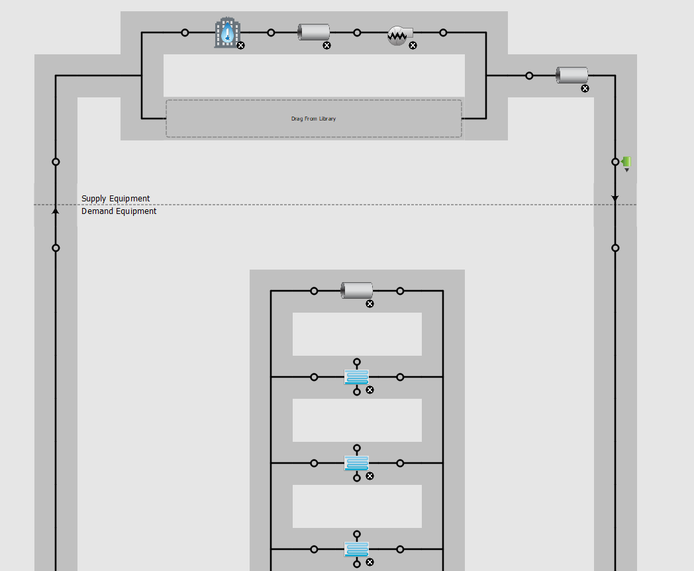

Figure 23. Chilled water distribution system.

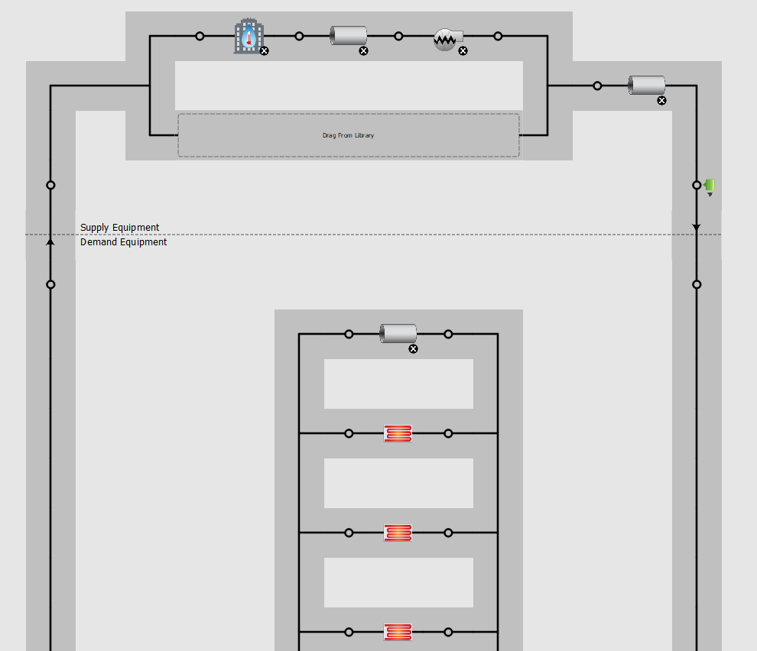

Figure 24. Hot water distribution system.

## 2. AHU (system)

The AHUs design coil capacity and air flow is shown in Table 10. The total coil capacity is $1.42×{10}^{6}$ $\frac{Btu}{hr}$. The AHU 6 provides most cooling capacity among all AHUs. Around 50% of cooling capacity are provided for cooling in interior zones.

|  |  |  |  |
| --- | --- | --- | --- |
|  | Serving area | Coil Capacity ($\frac{Btu}{hr}$) | Airflow (cfm) |
| AHU 1 | Floor 1 exterior zones | 1.24E+05 | 9598 |
| AHU 2 | Floor 2 exterior zones | 1.78E+05 | 13792 |
| AHU 3 | Floor 3 exterior zones | 1.79E+05 | 13873 |
| AHU 4 | Floor 4 exterior zones | 1.79E+05 | 13862 |
| AHU 5 | Floor 5 exterior zones | 2.03E+05 | 15777 |
| AHU 6 | Floor 1-5 interior zones | 5.57E+05 | 43261 |
| Total capacity | -- | 1.42E+06 | 80160 |

Table 10. AHU design coil/airflow sizing.

## 3. Terminal Boxes - TB (zone)

The Variable air flow terminal boxes is selected for OpenStudio simulation. The minimum primary airflow is set as 25%. Figure 25 shows the operation of reheat box as function of zone thermal load. The primary airflow is set to the minimum as heating is required in the zone. In OpenStuido, thee zone terminal boxes operation is configured as auto-sizing for both interior zones and exterior zones.

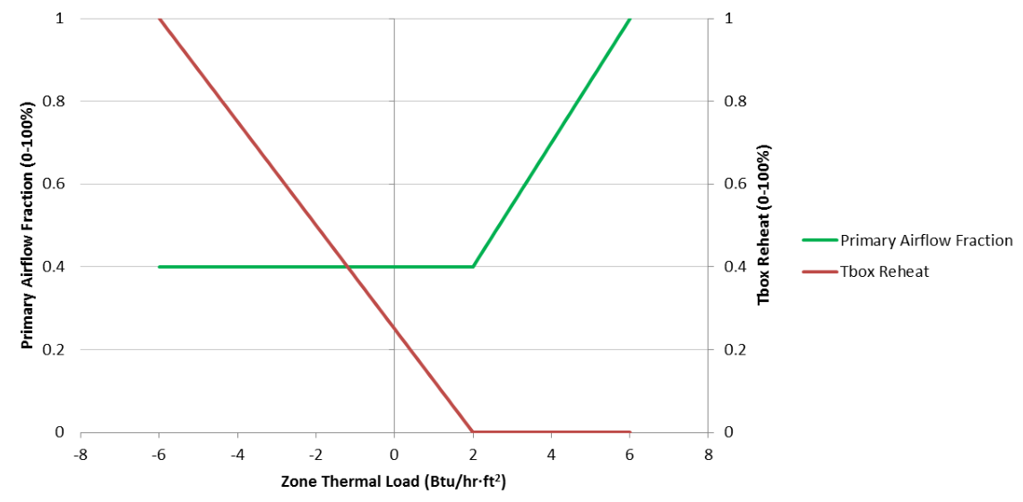

Figure 25. Reheat box operation with 40% minimum air flow (selected from WinAm reference book)

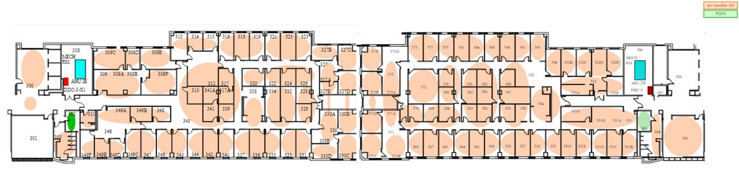

Figure 26. Thermal zone

Figure 26 shows an example of a thermal zone. The average temperature setpoint is calculated to be 74 °F. Based on the mechanical schedule, the design terminal box. The zone is auto sized based on winter design day algorithm and the zone required design sensible cooling can be found in Openstudio zone sizing calculation.

# IV. WinAM Modeling

The WinAm modeling parameters are summarized in Table 11.

## 1. AHU (system)

Total of five identical Single duct VAVAHUs are modelled to provide cooling to the space. The AHU are needed to provide design airflow of 12,500 CFM. The cooling coil is set to 45 °F. The static pressure for the primary fan is set to 3.5 inches. VFDs are used to reduce the fan energy.

## 2. Terminal Boxes (zone)

Terminal boxes reheat coil is needed to provide heating to the zone when heating is required. The reheat coil can also change the supply air temperature to the zone to meet the comfort requirement. The minimum primary air flow is set to 0.2 $\frac{CFM}{ft^{2}}$. The zone is controlled by thermostat that are set to 73 °F in summer and 71 °F in winter.

|  |  |  |  |  |  |
| --- | --- | --- | --- | --- | --- |
|  | AHU-1 | AHU-2 | AHU-3 | AHU-4 | AHU-5 |
| Design AHU (CFM) | 12,500 | 12,500 | 12,500 | 12,500 | 12,500 |
| Design water inlet temperature (°F) | 45 | 45 | 45 | 45 | 45 |
| Thermostat setpoint Cooling/Heating (°F) | 73/71 | 73/71 | 73/71 | 73/71 | 73/71 |
| Minimum OA percentage | 25% | 25% | 25% | 25% | 25% |
| Peak lighting ($\frac{W}{ft2}$) | 1.2 | 1.2 | 1.2 | 1.2 | 1.2 |
| Peak plug usage ($\frac{W}{ft2}$) | 1 | 1 | 1 | 1 | 1 |
| Peak Occupancy ($\frac{ft^{2}}{person}$) | 120 | 120 | 120 | 120 | 120 |
| VFD | Yes | Yes | Yes | Yes | Yes |
| Total static pressure (inch) | 3.5 | 3.5 | 3.5 | 3.5 | 3.5 |
| Minimum primary flow ($\frac{CFM}{ft^{2}}$) | 0.2 | 0.2 | 0.2 | 0.2 | 0.2 |

Table 11. AHU parameters(modeling).

# V. Calibration

## 1. WinAM Calibration

The calibration parameters for WinAm simulation are shown in Table 12. The monthly electricity, chilled water usage and hot water usage after calibration are plotted in Figure 27, Figure 28 and Figure 29. The simulated model achieved mean bias error of 3% for electricity, 10% for chilled water usage, and 52% for hot water usage.

|  |  |  |
| --- | --- | --- |
| Calibration steps | Before Calibration | After Calibration |
| (1). Floor area ($ft^{2}$) | $${144,400 ft}^{2}$$ | $${147,397 ft}^{2}$$ |
| (2). Exterior walls ($\frac{Btu}{hr ℉ft^{2}}$) | $$0.25$$ | 0.15 on average |
| (3). Exterior windows ($\frac{Btu}{hr ℉ft^{2}}$) | $$1.30$$ |
| (4). Thermostat setpoint ($℉$) | $$73/70$$ | $$71.9/70$$ |
| (5). Minimum primary flow ($\frac{CFM}{ft^{2}}$) | $$0.2$$ | $$0.11$$ |
| (6). Minimum OA percentage | $$20\%$$ | $$40\%$$ |
| (7). Coil setpoint ($℉$) | $$45$$ | $$56$$ |
| (8). Peak Occupancy ($\frac{ft^{2}}{person}$) | $$120$$ | $$90$$ |
| (9). Total heat per person ($\frac{Btu}{hr}$) | $$350$$ | $$350$$ |
| (10). Night electric | $$0.35$$ | $$0.30$$ |
| (11). Peak lighting/ Plug electric | $$1.50$$ | $$1.46$$ |
| (12). Interior zone percentage | $$40\%$$ | $$60\%$$ |
| CV-RMSE (Electricity/Cooling/Heating) | $3\% /$ 28 $\%/$ 71 $\%$ | $3\% /$ 10 $\%/$ 52 $\%$ |

Table 12. WinAm parameters before and after calibration

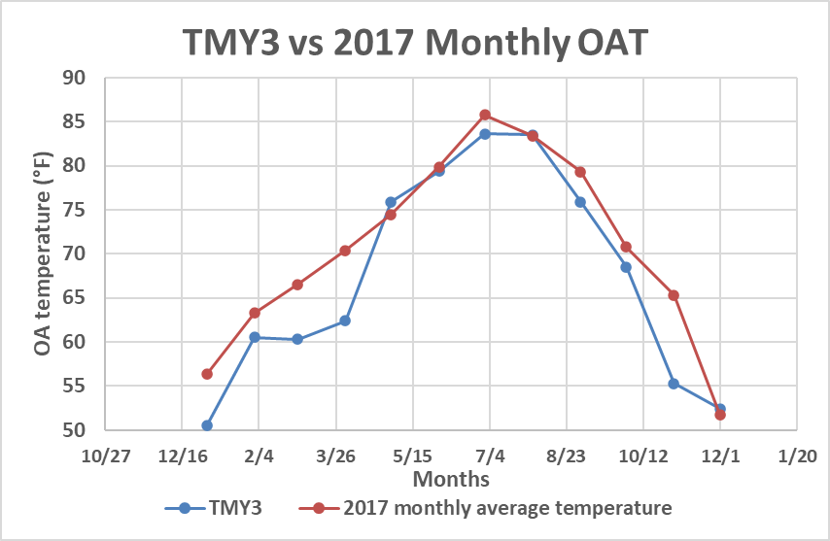

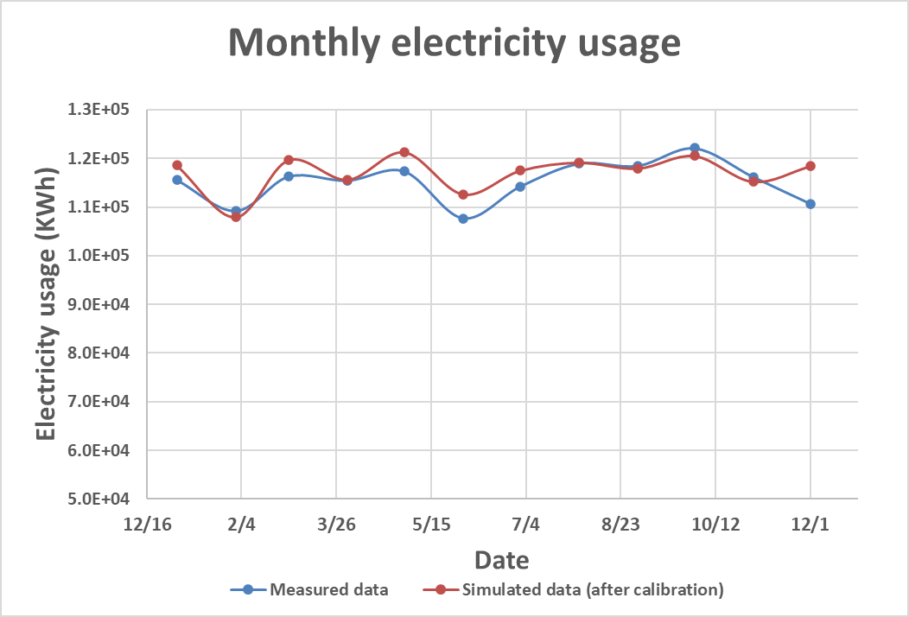

Figure 27. WinAm electricity calibration results

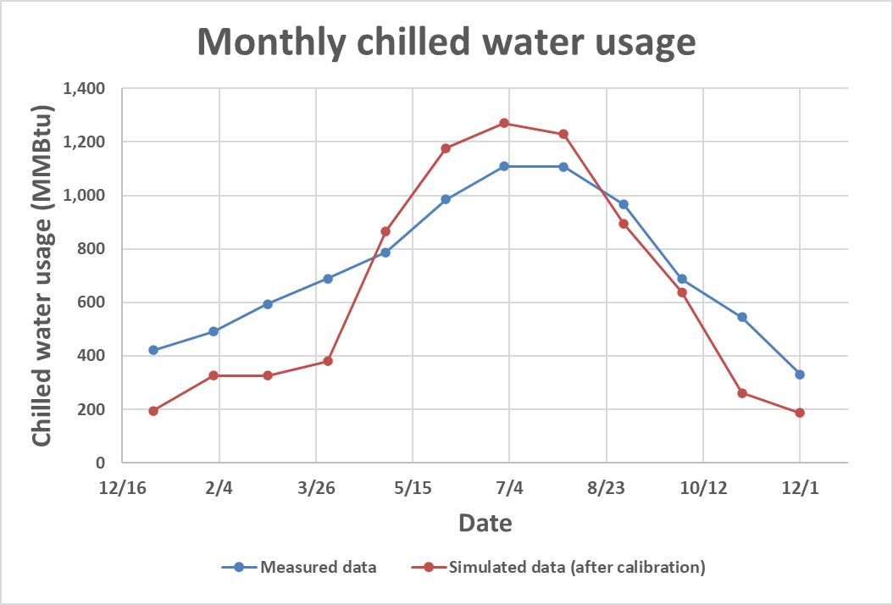

Figure 28.WinAm Chilled water calibration results

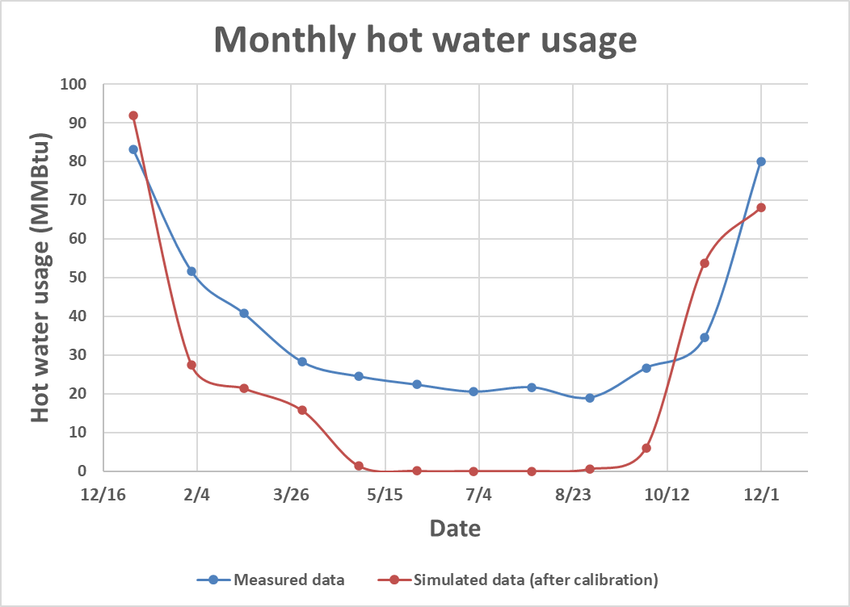

Figure 29.WinAm hot water calibration results

## 2. OpenStudio Calibration

The calibration parameters for OpenStudio simulation are shown in Table 13. The monthly electricity, chilled water usage and hot water usage after calibration are plotted in Figure 27, and. The simulated model achieved mean bias error of 6% for electricity, -2% for chilled water usage, and 17% for hot water usage.

$$MSE=\frac{1}{N}∑{\left(y-y^{'}\right)}^{2}$$

|  |  |  |
| --- | --- | --- |
| Calibration steps | Before Calibration | After Calibration |
| (1). Floor area ($ft^{2}$) | $${144,400 ft}^{2}$$ | $$144,400$$ |
| (2). Thermostat setpoint ($℉$) | $$73/70$$ | $$71/70$$ |
| (3). Night electric | $$0.35$$ | $$0.30$$ |
| (4). Peak lighting/ Plug electric | $$1.50$$ | $$1.46$$ |
| (5).Hot water setpoint | $$180$$ | $$165$$ |
| (6). Deck setpoint | $$55$$ | $$55$$ |
| (7). Zone supply air temperature | $$55$$ | $$59$$ |
| (8). HRV | Without HRV | With HRV |
| (9). Schedule modified | - | Office Occupancy schedule  Lighting Schedule  Equipment Schedule |
| MBE (Electricity/Cooling/Heating) | $10\% /$-22 $\%/$ 210 $\%$ | $6\% /$-2 $\%/17\%$ |

Table 13. OpenStudio parameters before calibration and after calibration.



Figure 30. OpenStudio electricity calibration results



Figure 31.OpenStudio Chilled water usage calibration results



Figure 32.OpenStudio hot water usage calibration results

# VI. EEM Opportunities

## 1. Building EEMs (system)

Adding overhangs to the building will save around 0.03% of energy based on OpenStudio calculation. Adding overhangs is majorly reducing the solar loads in the zones. It is not a efficient measure to the candidate building.

Using T-8 LED light bulbs instead of T-8 fluorescent light bulbs. This measure can save 18.8% of energy accumulatively. Using T-8 LED light bulbs (15 $\frac{W}{ft^{2}}$) is using only half of the energy as T-8 fluorescent light bulbs (32 $\frac{W}{ft^{2}}$). Replacing the light bulbs can reduce the internal loads in the zones. Reducing internal loads can save the use of the chilled water.

## 2. AHU EEMs (system)

Using economizer that operated during outside air dry-bulb temperature between 50 °F and 69°F can saves around 2.4% total energy. The cooling coil will be turning off when the economizer is drawing outside air into the system.

## 3. Terminal Box (zone) EEMs

The terminal box measure selected is to reduce the night plug loads from 30% to 20%. The accumulated energy saving is around 6.1%. Reducing night plug loads can change the electricity consumption of the building as well as the cooling energy usage. Using occupancy sensor can also be an effective way to reduce both lighting and electricity consumption in the zone.

# VII. Summary

## 1.Important Findings

The energy efficiency measures (EEMs) are summarized in Table 14.

|  |  |  |  |  |  |
| --- | --- | --- | --- | --- | --- |
| EEMs | Electricity usage (kWh) | Gas usage (MMBtu) | Total cost ($) | Total savings ($) | Percentage savings |
| Baseline | 1,475,948 | 9,139 | 416,377 | -- | -- |
| Add Overhangs | 1,474,868 | 9,139 | 416,231 | 145 | 0.03% |
| Use Economizer | 1,474,872 | 8,796 | 406,202 | 101,747 | 2.4% |
| Reduce night loads | 1,339,472 | 8,738 | 390,935 | 254,421 | 6.1% |
| Replace T-8 fluorescent lights with LED lights | 1,087,143 | 7,884 | 340,597 | 757,793 | 18.2% |

Table 14. EEM savings.

The calibration process for OpenStudio can be complicated compared to WinAm. Special cares need to be taken including the following:

(1). Building must be visited in order to get the occupancy, lighting and equipment schedule for calibrations.

(2). Measured data can be used to estimate the peak and valley electricity usage in the building in order to adjust the parameters to best represent the building.

(3). The coil setpoint, supply air temperature, the design flow rate of the system can be getting from the building energy management system or the design mechanical schedule.

The implementation of EEMs required more considerations on the whether the changes of the t equipment will influence the normal operation of the building. Using of economizer need special attentions on the outside air temperature and humidity ratio.

## 2. Recommendations for Future Work

It is suggested that using T-8 LED light bulbs to replace the currently using light bulb to save both electricity usage and cooling energy usage. The energy savings from this measure can be more than 10% with more than $50,000 operation cost savings. The simple payback rate can be less than 5 years. In addition, the occupancy sensor can also be used to further reduce the lighting in the building.

The building can also use Energystar computer and laptop to further reduce the electric equipment loads both during daytime and nighttime. The operation cost by this measure can be more than $10,0000.

Furthermore, it is suggested that the thermostat should be calibrated to the accurate value to improve the building operation and to best achieve savings with the discussed EEMs.

# References/Standards

ASHRAE Standard 90.1-2019. Available on www.ASHRAE.org, viewable for free.

ASHRAE Standard 62.1-2019. Available on www.ASHRAE.org, viewable for free.

ASHRAE Handbook of Fundamentals, Solar Heat Gain Factors (SHGFs) for selected latitudes of the northern Hemisphere, Retrieved from: https://cushman.host.dartmouth.edu/courses/engs44/SHGF-daily-totals.pdf

Desigo website. Retrieved, on April 12th, from:

https://bas-desigo-app.apogee.tamu.edu/Desigo-SUP-Flex-Client/loginpage

# Appendix A. AHUs and FCUs Description

We selected the key features of the AHU and FCU from the mechanical drawing schedules, as shown in Table 15 and Table 16. The list number of the drawing is M8.11.



Table 15. Air Handling Units Schedule



Table 16. Hydronic Fan – Coil Unit Schedule

1. The floor plans are the screenshots from the Desigo website. Retrieved, on April 12th, from: https://bas-desigo-app.apogee.tamu.edu/Desigo-SUP-Flex-Client/loginpage.
2. ASHRAE Standard 90.1-2019, Building Envelope Trade-Off Schedules and Loads, Retrieved from: https://web.ashrae.org/90_1files/pdfs/Addendum_an_Sched_and_Load.pdf?
3. ASHRAE Standard 90.1 – 2019, Section 9 – Lighting, Table 9.5.1, Retrieved from: https://ashrae.iwrapper.com/ASHRAE_PREVIEW_ONLY_STANDARDS/STD_90.1_2019
4. ASHRAE Handbook of Fundamentals, Solar Heat Gain Factors (SHGFs) for selected latitudes of the northern Hemisphere, Retrieved from: https://cushman.host.dartmouth.edu/courses/engs44/SHGF-daily-totals.pdf
5. ASHRAE Standard 62.1-2019, Ventilation for Acceptable Indoor Air Quality, Section 6 – Procedures, Retrieved from: https://ashrae.iwrapper.com/ASHRAE_PREVIEW_ONLY_STANDARDS/STD_62.1_2019